中等职业学校英语（二）期中英语试题

亲爱的同学，
欢迎参加中等职业学校英语（二）的期中考试。请您按照要求完成随后各页中的听力、阅读和语言应用的相关题目，检查自己在过去的半个学期的学习情况。
请同学们放松心情，认真作答。

祝同学们考出好心情，好成绩！

北京商务科技学校
Part 1 Listening1
Questions 1 – 2 (4 points)
Directions:
In this part, you will hear four dialogues. Listen, choose your answer and then circle your answer A, B or C under each dialogue.
Example
Dialogue A
A B C
Dialogue B
A B C

A. Hobbies
B. Jobs
C. Experiences

Questions 1
1 What are they talking about?
Dialogue A
A. Weekend plans
B. Job application
C. Holiday Experiences
A B C

Dialogue B
A B C

Question 2
A 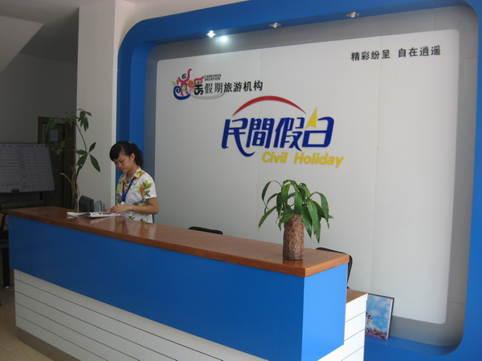
B 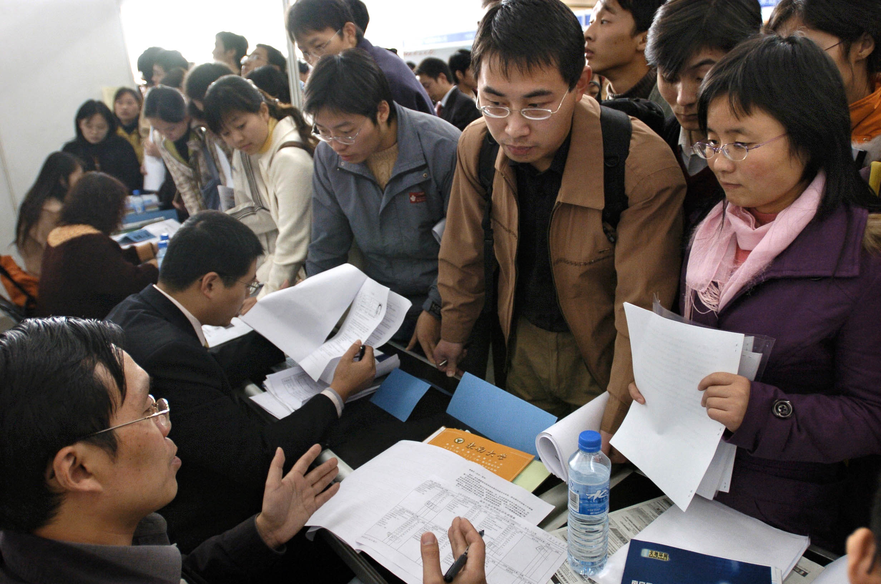
C 
C
Where do Dialogue C and D take place?
Dialogue C
A B C
Dialogue D
A B C
Part 2 Listening 2
Questions 3 – 6 (4 points)
Directions

In this part, you will hear a short dialogue between Mary and Jack. Mary is inviting Jack to do something. After the dialogue there will 4 questions, marked 3 - 6. Now please listen to Dialogue E and answer questions after the example.
Example:
Sara: What’s your hobby?
Jack: I love travelling to different places.
Q: What’s Jack’s hobby?
A. He enjoys cooking. B. He loves travelling. C. He prefers swimming.

3 What’s the problem with Jack?
A. He is ill. B. He is pale. C. He is

4 What does Jack prefer to do?
- Reading B. Boating. C. Dancing

5 What does Mary ask him to do?
- Go to the library B. Go boating. C. Go mountain climbing.

6. What does Jack decide to do at last?
A. Go to the library B. Join Mary C. Stay at home.

Part 3 Listening 3
Questions 7 – 10 (8 points)
Directions

In this part, you will hear a short dialogue between Li Xiaonian and Sara. They are talking about Li Xiaonian’s holiday. After the dialogue there are 4 questions, numbered 7 – 10. Now please listen to Dialogue F and answer questions after the example.
Example:
Sara: What did you do during the holiday, Jack?
Jack: I went mountain climbing.
Q: What did Jack do?
A.  B. 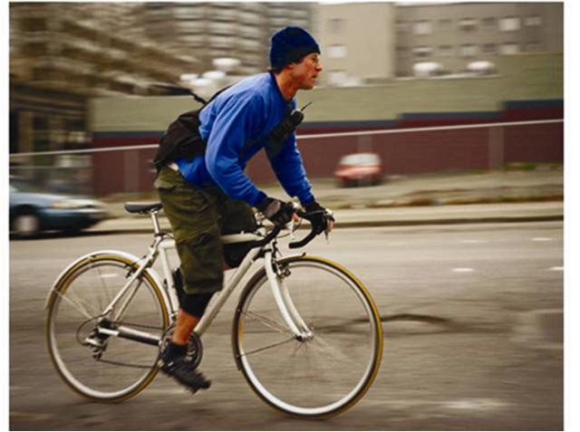 C. 

7. Where did Li Xiaonian go during the holiday?
A.  B.  C. 
8. How did he go there?
A.  B.  C. 
9. What did he do there?
A.  B.  C. 
10. How did he feel about the holiday?
A.  B.  C. 
Part 4 Listening 4
Questions 11 – 15 (15 points)
Directions:
In this part, you will hear a job interview. Listen to Dialogue G and complete the application form of David.
Example:
W: How old are you?
M: 18.
W: Where do you graduate?
M: Huiwen Middle School?
W: Can you speak English?
M: Yes. And I can write good English.
Listen and complete
Name | David
Age | ___18____
Education | Middle school
Abilities | Can speak English
Abilities | Can write good English

Application form

Personal information | Name: David  Sex: male
Post to apply for | 11: _____________________
Work experiences | Worked as  12: ________________ last summer
Attitudes towards traveling by train | 13: _________________
Hobbies | 14: _________________  15: ________________

Part 5 Communication
Questions 16 – 20 (10 points)
Directions:
In this part, you will read a dialogue between two speakers. Read the dialogue and choose the right expressions for each blank to make it complete.
Example:
W: (1)________A___________?
M: Nothing special. I went skating,
played volleyball with my friends.
(2)_________B_________?
W: I went to the south with my family.
- What did you do during the holiday?
- What about you?

M: Hi, Sara. Have you found your job?
W: Not yet. I am thinking. (16)___________ working in the IT company?
M: Good. But do you know IT. (17)____________ marketing?
W: Marketing? What do I do?
M: You can be a salesperson.
W: (18)________________ work in front of the computer.
M: But it is bad for your eyes.
W: Then, (19)______________?
M: I can use the computer quite well. I can send and receive emails.
W: That’s not enough. (20)_____________ take some courses.
M: No problem.

- What are your strong points?
- Why don’t you try
- I’d rather
- What do you think of?
- I think you should

Part 6 Language in use
Questions 31 – 35 (5 points)
Directions:
In this part, you will read 5 sentences about a student from Beijing Vocational School. Please choose the best word (A, B or C) to make them complete.
Example:
1. Jack is a ___________ student. He can always make new things.
A. creative B. outgoing C. relaxing.

31. Mike is _______________. He likes to talk with everyone.
A. outgoing B. hardworking C. creative

32. He does not like to stay at home during the holiday. He thinks it is _______.
A. typical B. moving C. boring

33. He often travels, but never takes the plane. He thinks it is ___________.
A. comfortable B. dangerous C. effective

34. He eats too much sweet food. ___________ he is now very fat.
A. That’s because B. That’s why C. That’s how

35. He decided to ______ a club to lose weight.
A. join B. open C. visit

Part Language in use
Questions (36 – 40) (10 points)
Directions:
In this part, you will read a short passage about Jack’s experiences. Choose words from the boxes and complete the passage with the right forms of the words given.
Example:
go climb eat

Jack (1)_______ to Beijing this summer. He (2)________ the Great Wall with his friends. He (3)___ _____ Beijing roast duck ….
- went (2) climbed (3) ate

advise, decide, take, contact, work

Many of Jack’s friends (36)__________him to take some part-time jobs during the holiday. Jack thought for a while and (37)________ to get some work experience before he graduates. He followed his friends’ advice. He (38)_______a lot of companies and finally chose a foreign company. He said, he could improve his English there. The working hours are long and it is far from school. It (39)_______ him two hours to go from school to the company. So he rented a room near the company to save money. He (40)__________ there for only two weeks and he can now speak very fluent English.
(36) _______________________
(37) _______________________
(38) ______________________
(39) ______________________
(40)_______________________
Part Writing
Questions 41 -44 (12 points)
Directions:
In this part, you will read an advertisement and something about Sara. Please read the advertisement and put the given sentences in the right place to complete the application letter for Sara.

Marketing assistant wanted
Creative
Hardworking

One year’s work experience
Good English
Male
20 - 30

Dear sirs,
I am a student from a vocational school in Beijing. I am boy of 23. I am (41)_________. (42) _____________________. During that time, I talked with foreign experts. (43) _____________________. (44) ___________________. I think I can be a marketing assistant.
Looking forward to your reply.
Best wishes!
Yours sincerely,
Sara

- am creative and hardworking
- I once worked in a foreign company as a salesperson.
- My English improved a lot.
- Now I can speak very good English.

What did you do?
How was the vocation?
Did you do anything special?
Have you ever done …?

What’s … like ?
What do you like to do?
It is …since
It take time to do something

Experienced,
Volunteer, spend, invite, order, advertise, post, share, save time, used to be, , join, stay up,

Keep somebody busy
Trip, a waste of time, marketing assistant, applicant, resume, traffic jams, rush hours, transportation, working hours

Such as, no longer

