中等职业学校英语（二）期末英语试题

亲爱的同学，
一学期的英语学习即将结束，也到了大家汇报一学期所学的时刻。请您按照要求完成随后各页中的听力、阅读和语言应用的相关题目，展示自己一学期的学习成果。
请同学们放松心情，认真作答。

祝同学们考出好心情，好成绩！

北京商务科技学校
Part 1 Listening 1
Questions 1 – 2 (4 points)
Directions: 听对话回答各小题，把正确的答案写在答卷上
In this part, you will hear four dialogues. Listen, choose your answer and then circle your answer A, B or C under each dialogue.
Example
Dialogue A
A B C
Dialogue B
A B C

A. Hobbies
B. Jobs
C. Experiences

- 听对话A和B，判断谈话发生的地点。
Dialogue A
A B C

Dialogue B
A B C

A. 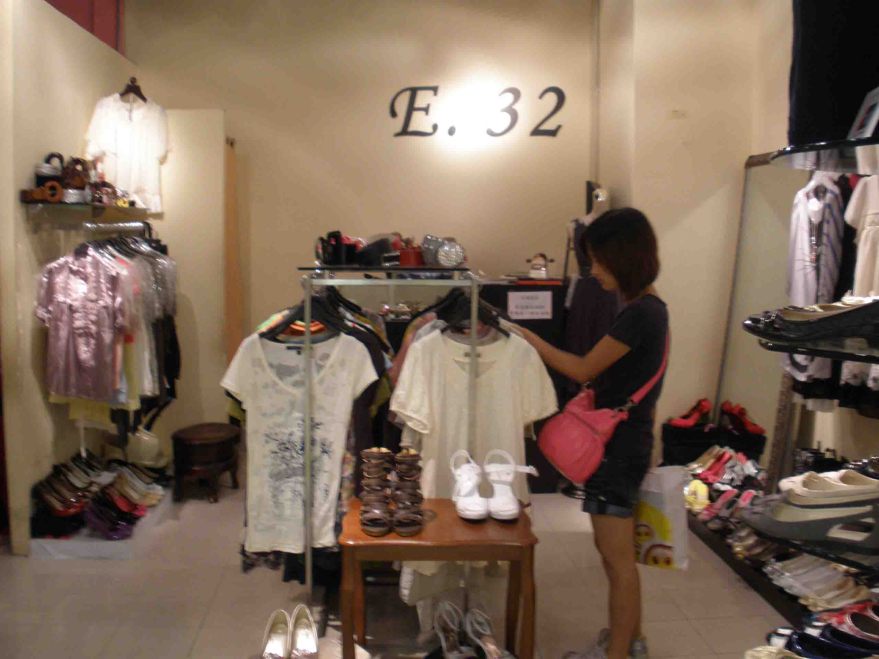 B. 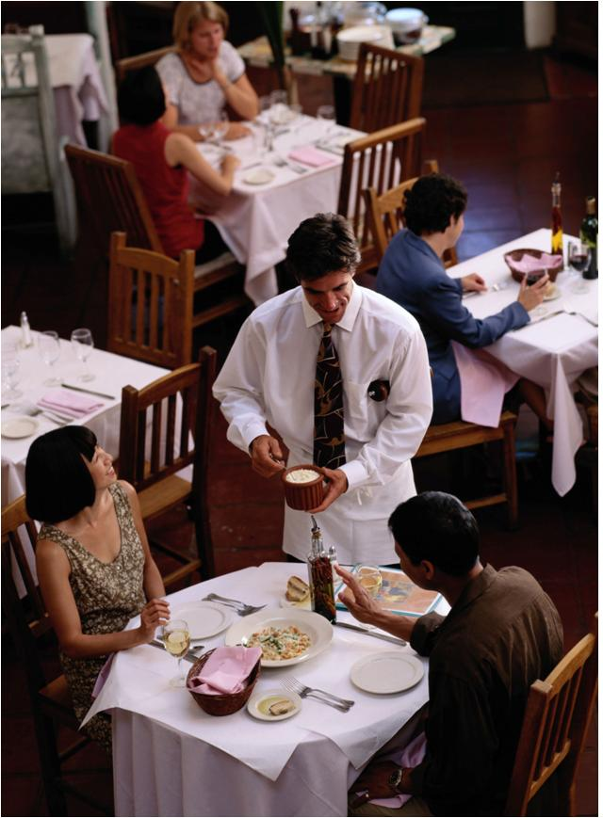C. 
- 听对话C和D，判断谈话的主题。
Dialogue C
A. Going shopping
B. Online activities
C. Travel plan

A B C

Dialogue D
A B C

Part 2 Listening 2
Questions 3 – 6 (8 points)
Directions 听一位女士的购物经历的对话E两遍回答下列各题
In this part, you will hear a short dialogue between a customer and a shop assistant. After the dialogue there will 4 questions, marked 3 - 6. Now please listen to Dialogue E and answer questions after the example.
Example:
Sara: What’s your hobby?
Jack: I love travelling to different places.
Q: What’s Jack’s hobby?
A. He enjoys cooking. B. He loves travelling. C. He prefers swimming.

- What does the woman want to buy?
A.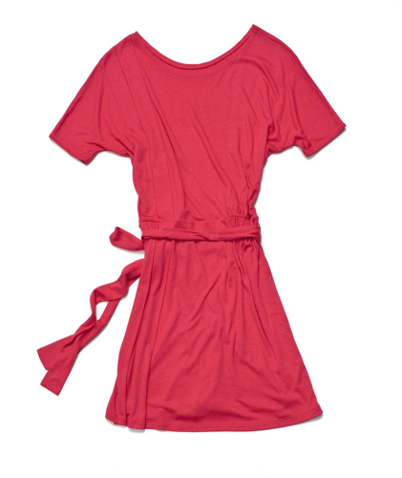 B. 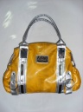 C. 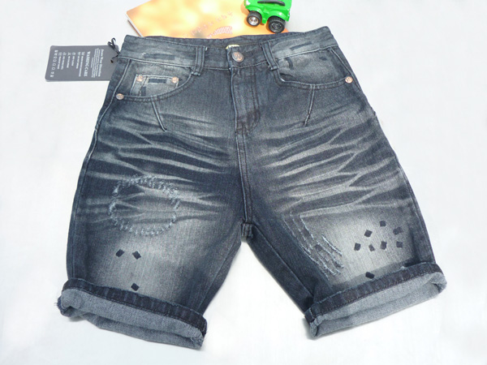
- Where is it made?
- 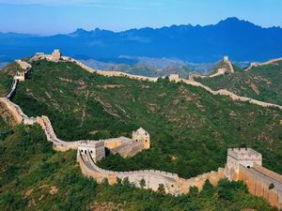 B.  C. 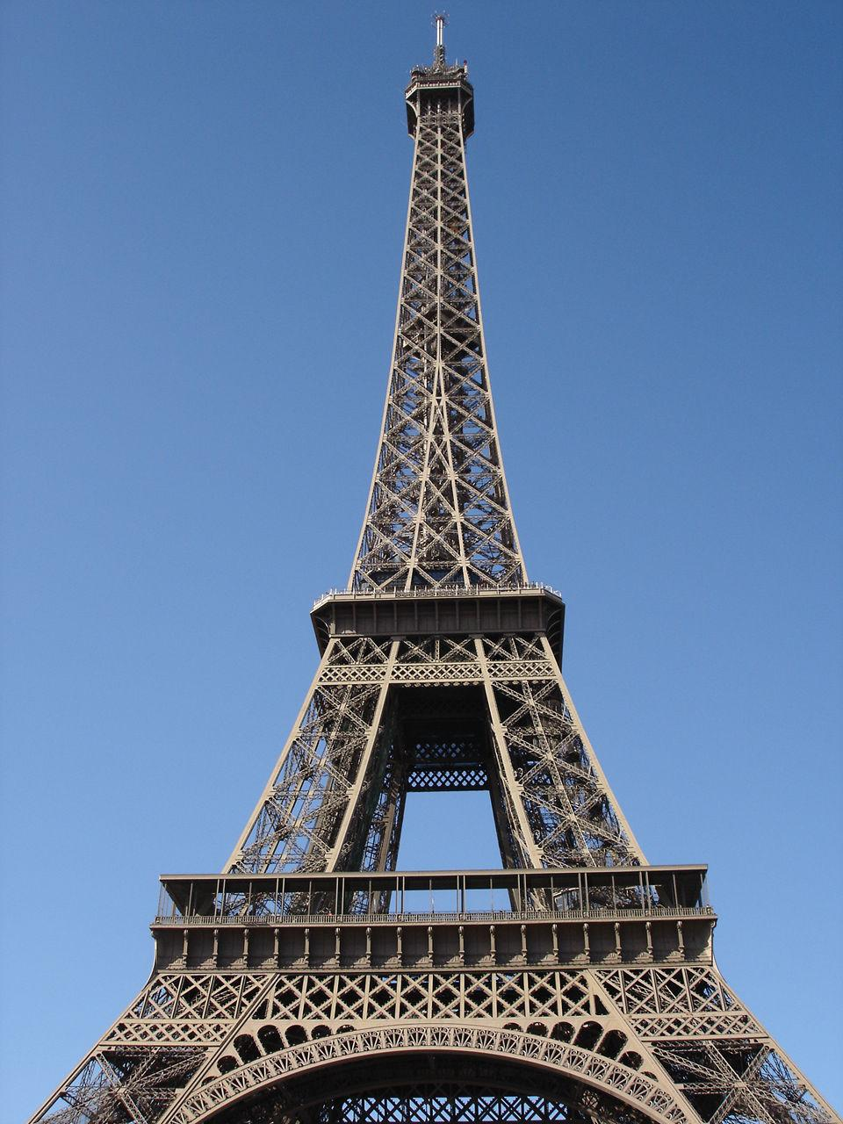
- What is it made of?
- 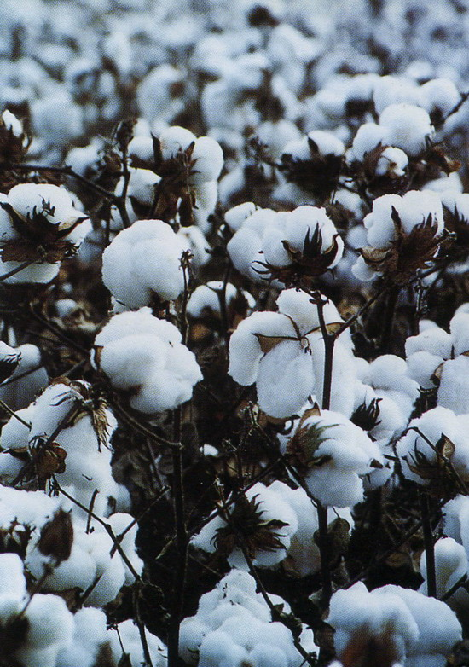 B. C. 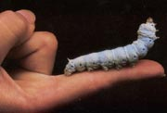
- How much is it?
- ￥280 B. $280 C. ￡280

Part 3 Listening 3
Questions 7 – 10 (4 points)
Directions 听对话根据旅游计划将所给事件排序。
In this part you will hear a dialogue about a travel plan. Listen to Dialogue F and put 7 to 10 in the right order according to the plan.
Example:
W: What are we going to do?
M: First, we’ll go shopping. Then we’ll go to climb the Great Wall. In the evening, we’ll go to a concert.
7.___B_____;
8._____C______;
9.______A_____

A. Go to a concert.
B. Go shopping.
C. Climb the Great Wall.

- _____________
- ____________
- ____________
- _____________

- Ride horses on the grassland.
- Enjoy the sunshine on the beach.
- Have a picnic.
- Climb mountains and enjoy the singing of birds.

Part 4 Listening 4
Questions 11 – 15 (10 points)
Directions: 听看病预约对话完成预约记录。
In this part, you will hear a dialogue between Tom and a nurse. Tom wants to make an appointment. Listen to Dialogue G and complete the appointment memo for the nurse.
Example:
W: How old are you?
M: 18.
W: Where do you graduate?
M: Huiwen Middle School?
W: Can you speak English?
M: Yes. And I can write good English.
Listen and complete
Name | David
Age | ___18____
Education | Middle school
Abilities | Can speak English
Abilities | Can write good English

Appointment Memo

Name of the patient | Name: Tom  Sex: male
Symptom | 11: _____________________  12. _____________________  runny noses
Experiences | 13: ________________  Played computer games
Doctor appointed with | 14: _________________
Time | 15: _______________
Contact | Mobile: 13591682138

Part 5 Communication
Questions 16 – 20 (10 points)
Directions 根据上下文选择适当的句子补全对话
In this part, you will read a dialogue between two speakers. They are talking about their holiday plan. Read the dialogue and choose the right expressions for each blank to make it complete.
Example:
W: (1)________A___________?
M: Nothing special. I went skating,
played volleyball with my friends.
(2)_________B_________?
W: I went to the south with my family.
- What did you do during the holiday?
- What about you?

Jack: Hello, Tom. (16）___________for this summer?
Tom: I haven’t decided yet. What about you?
Jack: I’m going to stay at home this summer.
W: (17) ___________________ ?
M: You know, I always catch colds and I have pains all over.
W: Yes. (18) __________________felt like this?
M: Nearly half a year. So, I’ve decided to go to see the doctor.
W: I hear our class is going to Hainan for a one-week tour. (19)__________ traveling together when you have seen the doctor?
M: That’s a good idea. (20)___________make it.
W:

- Hope I can
- What’s your plan
- How long have you
- What about
- What’s the matter
Part 6 Reading
Questions 21 – 23 (6 points)
Directions:阅读3段文章，根据每段文章的大意选出合适的主题。
In this part, you will read three passages. What are they about? Read the passages 21 – 23)and write the A, B, C, ...or F in the blank.
Example:
(1) I often listen to music. I like music.
I often download music from the internet.
I like singing and playing the violin too.
- A
- Hobbies
- Music
- internet

21.
Dear Mrs. Lawson,
I am sorry that I can’t come to school today. I have caught a bad cold and I feel terrible. Yesterday I had a football match with my classmates and I was wet all over. Then I took off my sweater and went home. After dinner, I felt terrible and got a fever. The doctor gave me some pills and asked me to have a good rest. I hope you can give me a leave.
Yours, Jack

22. The Great Pyramid is the largest pyramid on earth. It is located in Egypt. More than 100, 000 men worked to build the Great Pyramid. There are many closed doors in the Pyramid. People have tried to use robots to discover the secrets.

23. After breakfast, Jane went to a big shopping mall to buy a CD player. She found a very good one designed just for young ladies. In the afternoon, she went to a supermarket to buy a pair of sunglasses. They were fashionable. In the evening, Jane went back home and found that all the things she bought were made in China.
- Changes of work
- A note for sick leave
- Healthy activities
- Description of places of interest
- Shopping experience

21. ________________

22. _______________

23. __________________
Part 7 Reading
Questions 24- 28 (5 points)
Directions:阅读某旅行社的一日游计划，把旅行计划中的活动按时间先后排序。
In this part, you will read a passage about a one-day tour plan. You are to arrange the activities in the plan in the right order and write the numbers A, B, .. or E in the right place (24 – 28) as in the example.
Example:
In the morning you can visit the American Museum of Natural History. At noon, you can enjoy a great piece of pizza. In the afternoon, you can go to Greenwich Village to have a walk….
- ____A____ (2) ____C____ (3) ____B_____
- visit the American Museum of Natural History
- have a walk in Greenwich Village
- enjoy a great piece of pizza

Beijing is an ancient and modern city. Many greatest attractions are located in Beijing. If you only have one day for sightseeing after your business matter, we can arrange many 1 day tour lines for your reference. The following one is a nice choice.
In the early morning, we will start the day by watching the flag-raising on Tiananmen Square. After breakfast we will visit the Forbidden City for 2.5 to 3 hours. After lunch in a nice restaurant, we will visit the Olympic Park. In the afternoon, we will visit the inside of Bird Nest and Water Cube. Finally in the evening, we’ll enjoy the night view of Chang’an Street.
- visit the Forbidden City
- watch the flag-raising
- visit the inside of Bird Nest and Water Cube
- visit the Olympic Park
- enjoy the night view of Chang’an Street
24. _____________
25. _____________
26. _____________
27. ____________
28. _____________

Part 8 Reading
Questions 29 – 32 (4 points)
Do you like shopping on-line?：阅读Alice, Mike, John and Emma关于网上购物的帖子，并将他们的观点匹配。
Read people’s different opinions about shopping on-line. Match their names with their opinions.
Alice I’m 20 years old. I like shopping on-line. I just look through the items on line and choose what I want. Several days later I will receive what I ordere on line. It’s convenient.

2010-5-20 21: 18

Mike I don’t agree with the host. If you go shopping on line, you can only see the pictures, not the real items. So you may get cheated(欺骗).

2010-5-20 21: 20

John I agree with Mike. Shopping on-line sometimes is not convenient at all. For example, you can’t try on the clothes when you shop on-line.

2010-5-20 21: 25

Emma I agree with the host. Shopping on-line can also save you a lot of money. Things on-line are usually much cheaper. So I like shopping on-line, too.

2010-5-20 21: 29

29. Alice A. shopping on-line cannot be trusted
30. Mike B. shopping on-line is convenient
31. John C. shopping on-line can save a lot of time
32. Emma D. shopping on-line sometimes is not convenient.
Part 9 Reading
Questions 33 – 38 (12points)
Directions:阅读医生日记，填写当天的病人档案。
In this part, you will read the diary of Doctor Smith. Suppose you are the assistant of a doctor. Please fill in a file of these people for the doctor.

Today I have three patients. No. 1 is Betty, a beautiful girl student. She said she coughed all the time for about 3 days. After a careful check, I told her she had a cold, but not very serious. I told him “Take this medicine 3 times a day, drink more water and stay in bed for a good rest”.
Next one is Peter, a tall PE teacher. He told me he had a terrible toothache. I checked his teeth carefully and said “It’s not serious. Take the pills twice a day, you should brush teeth more often and eat less sweets. You’ll be better soon.”
The last one is Bob, an engineer. He told me he had a bad stomachache from this morning. I checked and asked what he had for dinner, he said he had some rice with chicken and vegetables, and had a large cup of ice tea. I told him “it’s nothing serious, remember not to eat warm food with much ice drink, it’s not good for stomach.”
Name：Betty Job：student
Symptoms（症状）：(33)___________________
Treatments （治疗）：Take medicine 3 times a day, (34)___________ and stay in bed
（治疗）

Name：(35) Job：PE teacher
Symptoms（症状）：a terrible toothache
Treatments （治疗）：(36) ____________, brush teeth more often and eat less sweets
（治疗）

Name：Bob Job：(37)________
Symptoms（症状）：(38)________________
Treatments （治疗）：not to eat warm food with much ice drink

Part 10 Language in use
Questions 37 – 41(5 points)
Directions:
阅读Susan针对朋友的旅游计划给出的建议，选择合适的答案使句子意思完整。
In this part, you will read 5 sentences about the suggestion of travel plan. Please choose the best word (A, B or C) to make them complete.
Example:
1. You should know___________ you can go to travel.
A. when B. who C. while.

37.First, you should decide you will go with to travel.
A. how B. when C. who

38. And then, you can discuss _______ you want to travel.
A. where B. that C. who

39.Next, you should think ___________ you can get there.
A. what B. how C. where

40. ___________ you make a decision, you have to prepare the things to take.
A. Once B. That C. What

41. Finally, you may have a good time ______ the weather is terrible.
A. if B. as long as C. unless

Part11 Language in use
Questions 42 – 51 (10 points)
Directions: 阅读Jack的博客，选出适当的答案使文章通顺。
In this part, you will read Jack’s blog. You are to read the choices marked A to J and choose the right one for each blank to make the blog complete.
Example:
I (1)________music. I often (2)_______music from the Internet. And I (3)___________ some friends online.
(1).C (2) A (3) B
- have made
- listen to
- like

As long as I am free, I like (42)_________ online. Films are my favorite. I often(43)__________films from the Internet. Last night, I met a good friend in a chat room. I (44)________ with him online for a long time. This morning, I felt cold and I thought I (45)___________ a fever. I (46)_______ an appointment at once and went to see the doctor this afternoon. The doctor asked me to take the temperature. After a while, he told me that I should (47)_______ the medicine twice a day. At last, the doctor (48)_______ me to drink more water and have a good rest. From now on, I should (49)______less than two hours online every day. And I think I can do some other things online. I can(50)___________some listening material to improve my English. I also can (51)_______________ emails to my friends.
- chatted
- take
- send
- had
- search for
- download
- advised
- going
- made
- spend

42._____ 43. ______ 44. ______ 45. _______ 46. _______
47. _____ 48. ______ 49._______ 50._______ 51. _____

Part12 Language in use
Questions (52 – 56) (10 points)
Directions:阅读关于某大学图书馆的介绍，选用所给单词的正确形式填空。
In this part, you will read a short passage about the introduction of a university. Choose words from the boxes and complete the passage with the right forms of the words given.
Example:
sell buy make
I (1)_______ a skirt in a shop yesterday. Here’s the beautiful skirt. It is very beautiful. And it (2)________of cotton. The skirt (3)________ at a very low price now.
- bought (2)is made (3) is sold

design, relax, book, take, copy

The library has more than two million items in its collection. It is located in the southeast of the university. The building (52)________ by a famous designer in China. It is very beautiful. It was completed in 1978. Here, you can borrow books, read books online and also (53)________in the coffee room. You can also (54)______ and renew books and magazines online. It (55)______ you only a few minutes to finish all the task. But remember only Chinese books can be taken out, English books and magazines should be read in the library or ________.
(52) _______________________
(53) _______________________
(54) ______________________
(55) ______________________
(56)_______________________
Part 13 Writing
Questions 57 -61 (12 points)
Directions:
In this part, there is a brochure of a two-day work plan. Please read the brochure and complete the introduction of the travel plan.

Day 1 Morning
Visit the Development Center

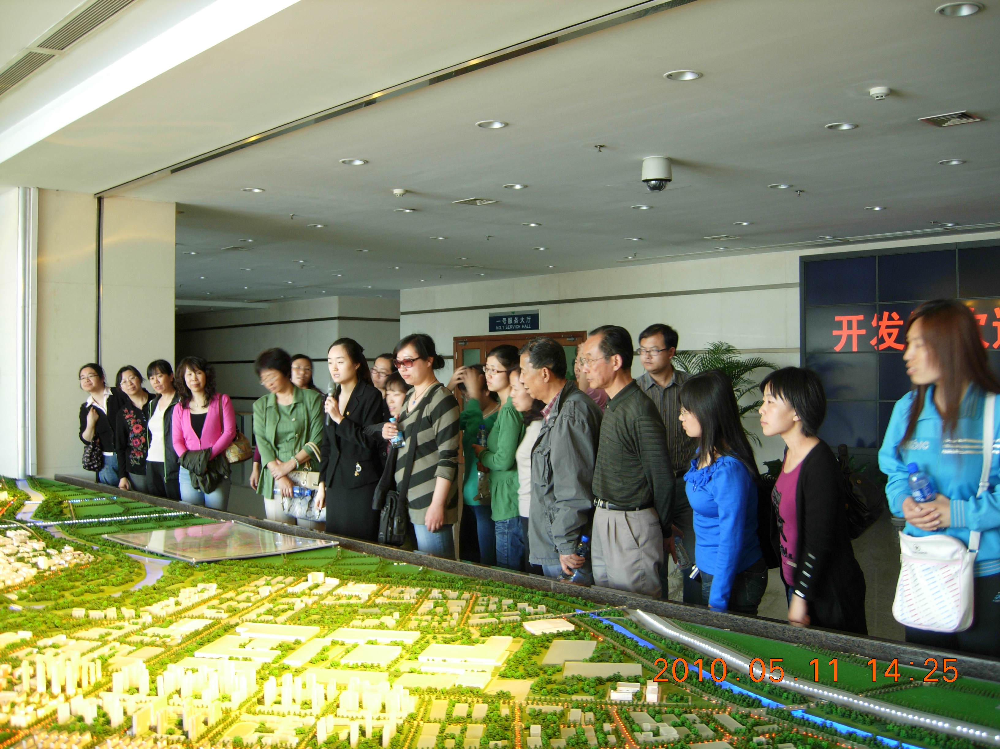
Day 2 Morning
A meeting to discuss the visit

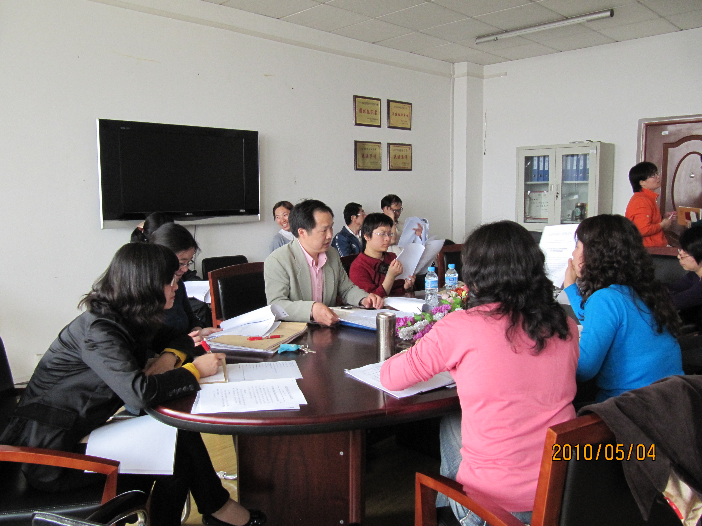
Day 1 Afternoon:
Visit new countryside
Day 2 Afternoon:
Skill competition
Two-day work plan of the company

Day 1
We’ll (57)_____________________ in the morning. It’s the first development Center in our city. We’ll visit the Software companies and the medical factories. (58)________, (59) __________________ in the suburb. We can pick fruits and vegetables there.
Day 2
We’ll hold a meeting (60) __________. At the meeting, we can talk about what we see and experience in this activity. (61) ___________, (62) _____________. It’s the second time that we have held such competition. Everyone is welcome.

